## Fontys University Of Applied Sciences

Project Report

Student Housing BV Panel



**Software Engineering**

**Project Group 01**

​​

Made by:

*Martin, Ionut, Nikolay*

Eindhoven

2 0 2 3

Table of Contents

**1. Introduction**3

**2. Background**3

**3. Problem definition**3

**4. Working process**4

**5. Final result**6

**6. Conclusion**11

**7. Future improvements**11

**8. Reflection**12

8.1 Ionut 12

8.2 Nikolay 12

8.3 Martin 13

# Introduction

The purpose of this project is to design and develop a software application, named "Student Housing BV Panel", that addresses the challenges faced by Student Housing BV and their clients. The application will be built using Windows Forms and will aim to provide a scalable, easily maintainable, and user-friendly solution for both agency employees and clients. The software will be divided into two main sections: "Student Panel" and "Admin Panel", each catering to the specific needs of the respective user groups. The ultimate goal of this project is to deliver a software that has good performance, great usability and helps to improve the overall experience of using Student Housing BV services.

# Background

Student Housing BV is a company that owns and manages student housing buildings in the Netherlands. These buildings offer rooms for rent to students, as well as shared facilities such as toilets, bathrooms, kitchens, hallways, and storage spaces. However, the company has been receiving complaints from its clients related to the inappropriate behavior of some of the students living in these buildings. The complaints range from littering common areas to making noise late at night, which can affect the overall living experience of the other tenants. In light of these issues, Student Housing BV has decided to seek a software solution that can help better manage day-to-day situations and alleviate the problems mentioned above.

# Problem definition

Student Housing BV has been receiving a number of complaints from its clients regarding the cleanliness and maintenance of the shared facilities in their buildings. These complaints include issues such as appointed persons not cleaning the shared facilities, groceries not being done or paid for shared items such as toilet paper and dish soap, and garbage not being disposed of on time. Additionally, tenants have also reported unannounced parties and gatherings taking place in the buildings, which can cause disruptions to the overall living experience. The company believes that these problems are affecting the overall satisfaction of its clients and are in need of a solution. Furthermore, the company assumes that there are other minor problems that are occurring but have not been communicated by the clients.

# Working process

The working process for this project was divided among the members of the student project group. The interface work was split evenly, with Martin working on the admin panel and login section, Ionut working on the tasks, rules, and account page, and Nikolay working on the agreements page. This allowed each member to focus on specific areas of the application and ensure that the interface was cohesive and user-friendly.

In addition to working on the interface, all members of the group also contributed to the creation of classes and the database. This was done simultaneously to ensure that everyone had a good understanding of what we were dealing with and to facilitate communication between members.

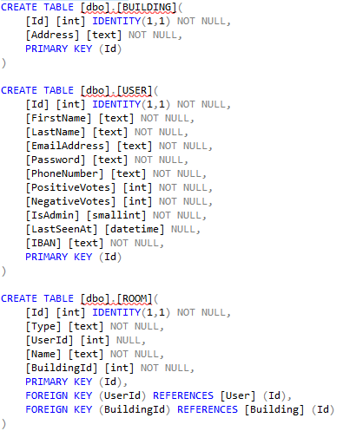

* a section of the creation script for the database

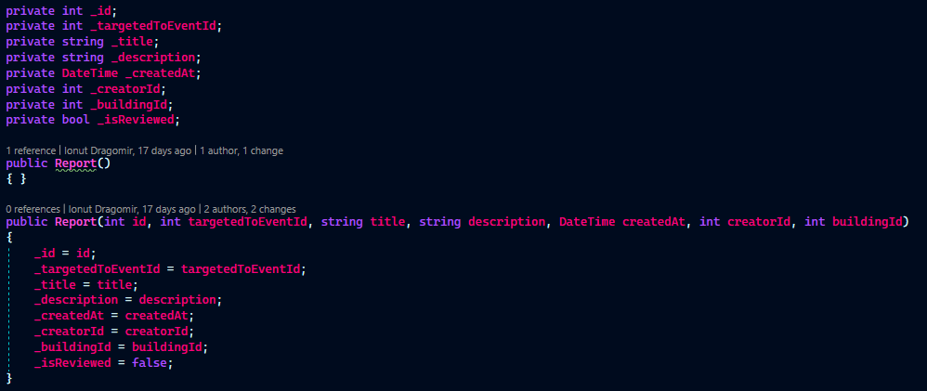

* example of a class

To ensure that the project was completed on time, we set up three meetings and sets of milestones to achieve by the deadline. This was all written in a shared Google Docs Spreadsheet, constantly updated by us while we kept finishing our work.. However, we often found that we were not able to complete everything on schedule. Despite these delays, we were able to achieve every goal that we set, thanks to our skills and motivation to create the best work we could.

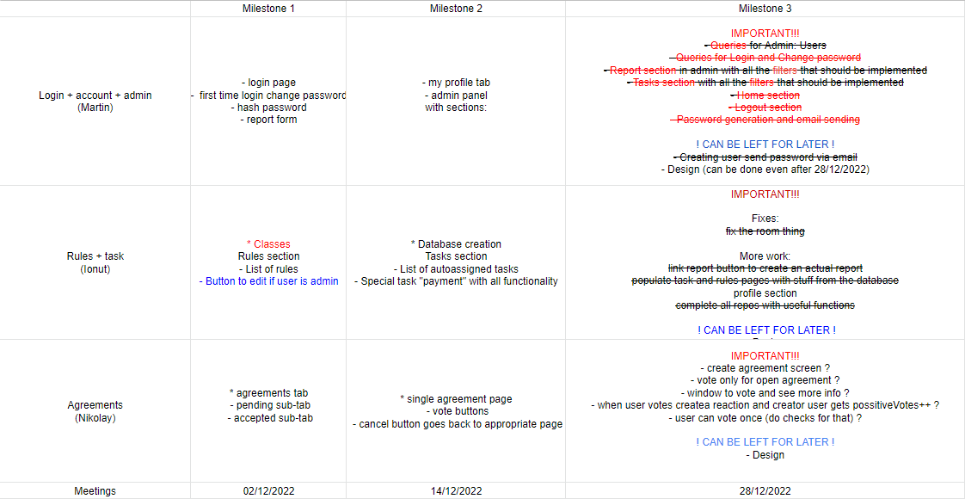

* the spreadsheet used for the scheduling

In addition to our in-person meetings and milestones, we also set up a WhatsApp group for communication, a Google Drive Shared Library for storing all of the files related to the application, and a GitLab Repository for uploading and sharing our work on the application. These tools allowed us to collaborate and stay on the same page even when we were not able to meet in person.

During the holidays, we also set up Discord calls where we put together our pieces of software and where we could call for help if needed. This allowed us to continue working on the application even when we were not physically together and helped us to stay on track towards our goal of completing the project on time.

# Final result

The purpose of this software application is to help manage and organize shared responsibilities within a student housing complex, specifically addressing issues of cleaning, purchasing shared items, and disposing of garbage. It aims to ensure that designated individuals are held accountable for their assigned tasks, that shared items are purchased and replenished in a timely manner, and that garbage is disposed of regularly. It also includes features for announcing gatherings and parties. The application is designed to help improve communication and organization among residents, and address common problems that arise in shared living situations. On the other hand, the application aims to help agency administrators manage the above mentioned tasks, house rules and reports.

The application consists of a login page, where users can log in with their credentials. Once logged in, users are directed to either the student panel or the admin panel, depending on their status.

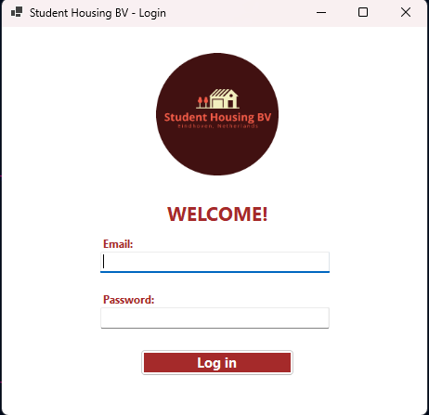

The student panel has four tabs:

* Agreements: Users can propose different actions that would take place in the future, such as parties, gatherings. The other users that reside in the same building as the one which proposed can vote on that agreement, and if it is accepted by 75% of them, it becomes accepted and closes itself.

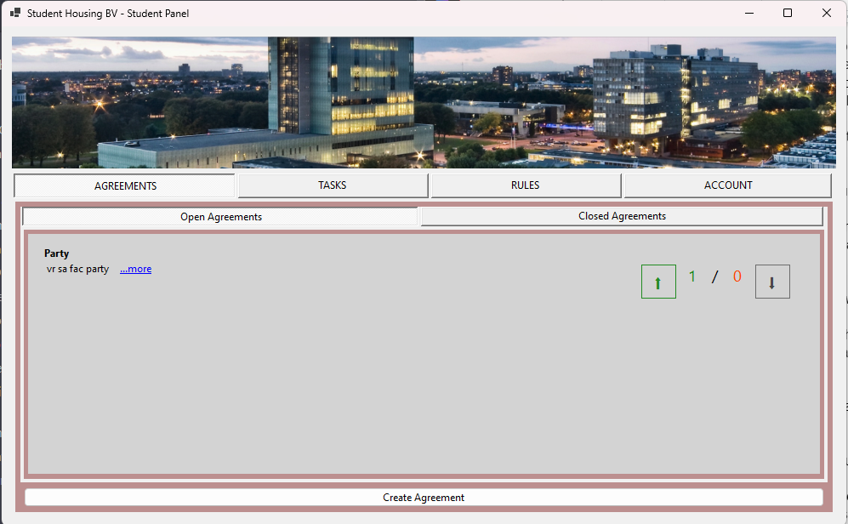

* Tasks: Users can see which tasks they are assigned to do and can view the status of their completion.

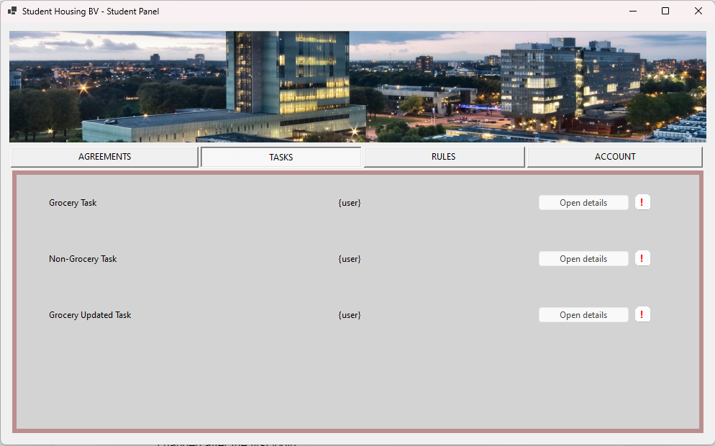

* Rules: Users can view the rules of their building, which the admin can edit.

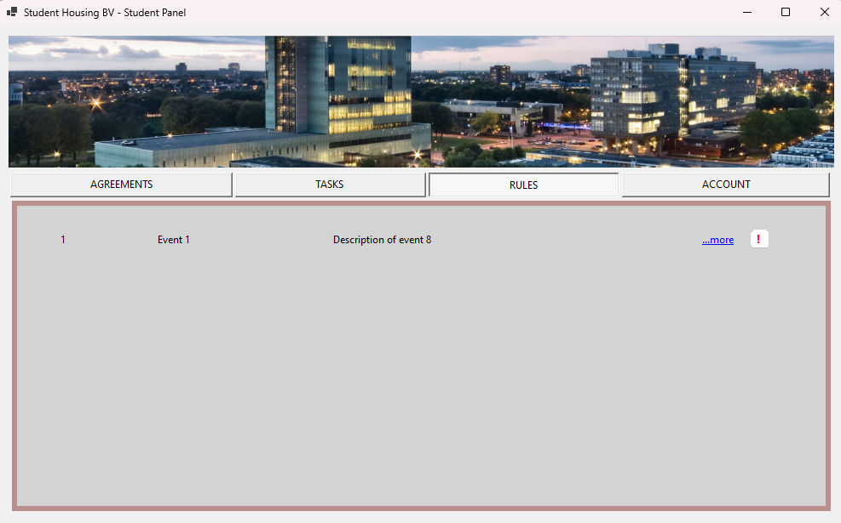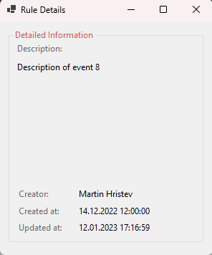

* Account: Users can see their account details, including their email and phone number, and make changes as necessary.

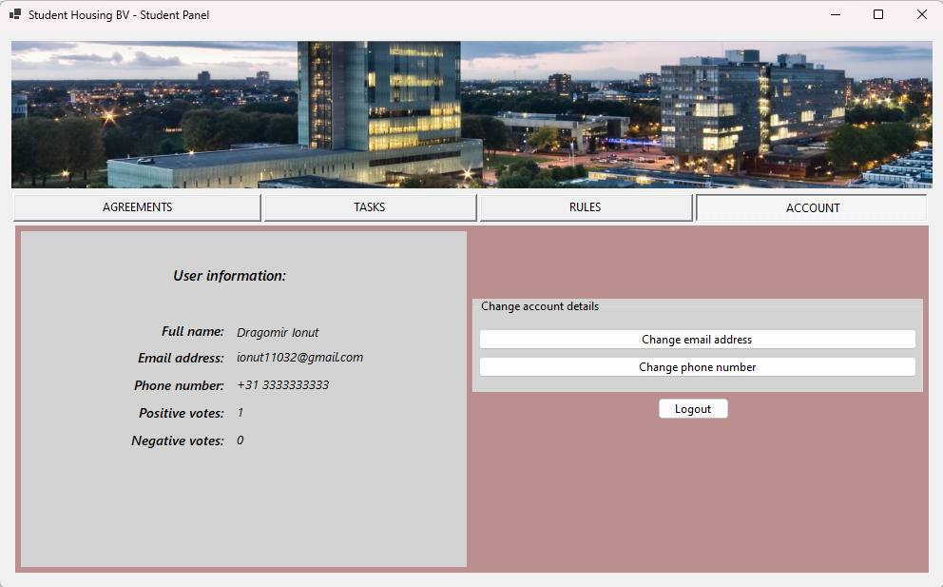

The admin panel contains the following pages:

* Users: Admins can view all the users and create new ones. After creating a new member, it will receive an email with a temporary password, which will be changed after the first login.

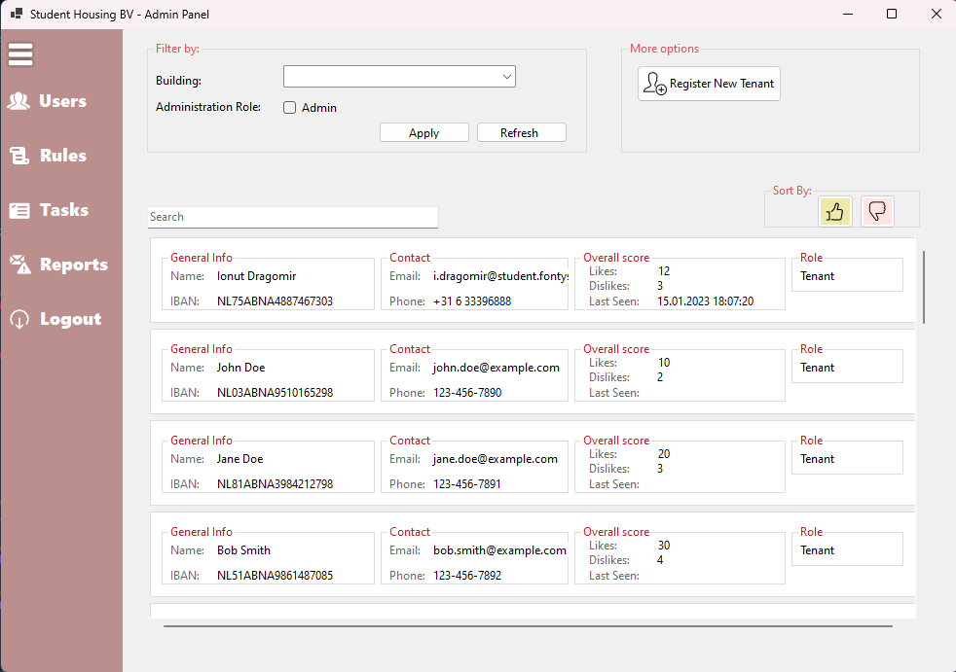

* Tasks: Admins can edit the tasks, manage the shopping tasks, and review the completion status.

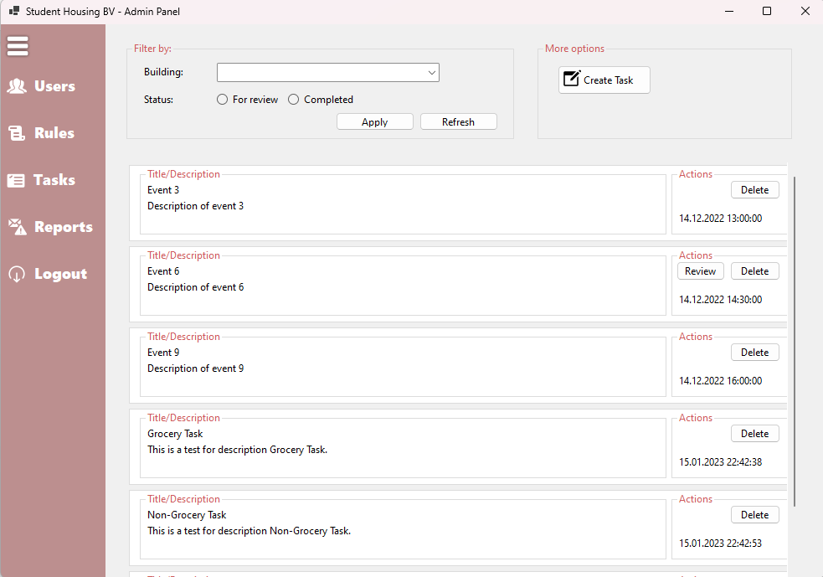

* Rules: Admins can edit the rules of the buildings.

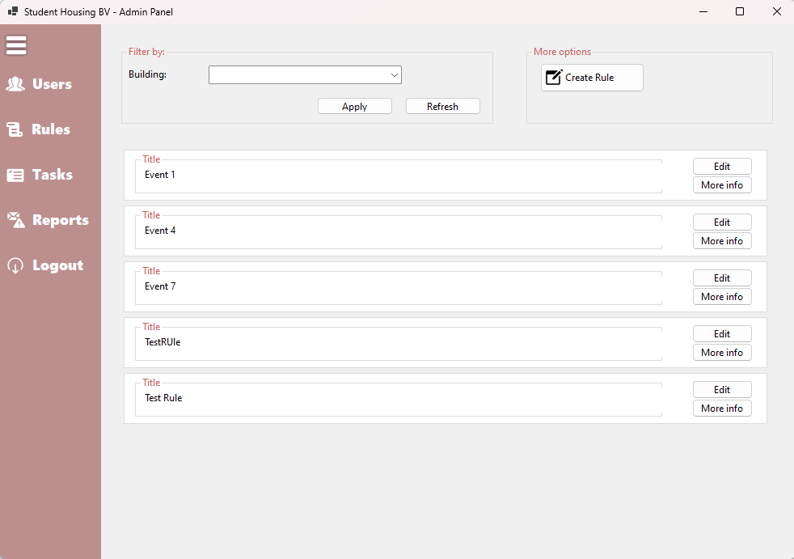

* Reports: Admins can manage the reports from all the buildings and take appropriate measures to ensure that no other problems will occur.

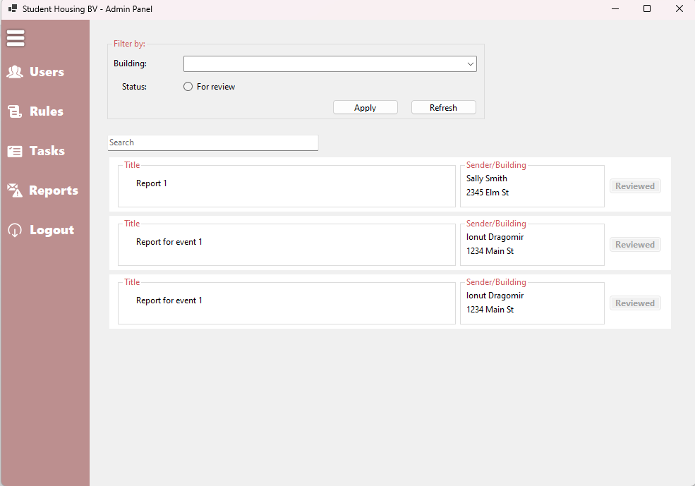

From a technical perspective, the software application was written using C# programming language. Its user interface is developed using Windows Forms, containing multiple forms, panels and tabs. The back end consists of a Microsoft SQL Server Database, hosted online so the users have access to the application at any time. The connection between the front end and the back end is made using specific libraries in the code.

The application was tested continuously during the development and after completion. User testing showed that the application was easy to navigate and provided a clear overview of the tasks and agreements. Based on the feedback, some minor improvements were made to the user interface. Performance testing showed that the application can handle a moderate number of users without any significant delays. The application was also found to be scalable, enabling the addition of multiple buildings and rooms, and reliable. Security testing revealed that the application is secure and protects user data, thanks to the usage of a password hasher which is used to store the user’s personal data in the database.

# Conclusion

In conclusion, the software application developed in this project aims to solve the common problems of shared student housing, such as cleaning, groceries, garbage, and unannounced parties. The application provides a user-friendly interface for students to propose items, view their assigned tasks, and check the building's rules. The admin panel enables the admin to manage the users, tasks, rules, and reports, making it easy to keep track of the shared housing.

The application is, to an extent, complete - all essential features are working as expected. There are things to be desired from the user interface, but it provides an unambiguous intuitive experience usable by anyone.

# Future improvements

Looking ahead in the future, the team will continuously keep updating the application. The next updates will surely include the following features: working weekly assignment of users to the tasks, uploading images in the grocery task. Improvements for the design will also be taken into account for the following iterations of the application, with the possibility of a big overhaul of the student panel.

# Reflection

## 8.1 Ionut

This project group was a great learning experience for me. One of the most significant quirks of this project was that we overcomplicated our solution, which resulted in us working more than we had anticipated. We spent a lot of time trying to perfect certain features, and it ended up taking away from other important aspects of the project. However, the communication between us was great and we were able to work through it as a team.

Even though there were a lot of delays in the writing of the code, the evolution of the application went smoothly. We were able to work together to overcome any challenges that arose. Our structure of the code was well thought out, like on a real project, which helped us to maintain the quality of the application.

Overall, this project changed my whole perspective of a project group and how the organization should happen. I learned the importance of clear communication, time management, and having a well-structured plan. I also learned that sometimes, less is more, and that it's important to keep the goal in mind and not get bogged down by unnecessary details. I am grateful for this experience and the lessons learned, and I look forward to applying them in future projects.

## 8.2 Nikolay

Working on a group project for a software engineering class was a valuable experience. Although the code ended up being over-engineered and the organization of the project was lacking, the final outcome was still great. The complexity of the code made it challenging to understand and work with, but it also provided an opportunity to learn more about problem-solving and how to simplify code. The lack of organization made it difficult to coordinate and communicate effectively, but it also taught me about the importance of clear communication and project management. Despite these challenges, the group was able to work together effectively and deliver a successful project. Overall, it was a great learning experience and one that I will take with me in future projects.

## 8.3 Martin

Reflecting on the group project, it is clear that we all brought a wealth of experience and expertise to the table. Each member of the team had a unique perspective and set of skills that contributed to the overall success of the project. We were able to collaborate effectively and come up with innovative solutions to the various challenges that we faced. However, despite our collective experience and knowledge, communication within the group was not always as clear as it could have been. This resulted in some confusion and delays in the progress of the project.

One of the major issues we faced was that milestones were not always taken as seriously as they should have been. This resulted in some members of the group falling behind schedule and causing delays for the rest of the team. This was particularly problematic when it came to deadlines for deliverables and progress reports. Despite these challenges, we were able to learn from one another and adapt our approach to better suit the needs of the team.

The final product of our group project is of high quality and can be attributed to the dedication and hard work of each member of the team. We were able to deliver an end product that is easy to scale and can be adapted to a variety of different situations. This is a testament to the knowledge and experience of each member of the team, as well as our well-designed architecture.

Overall, the group project was a valuable learning experience for everyone involved. Despite the challenges that we faced, we were able to come together as a team and produce a high-quality end product. The group project was a great opportunity to learn new skills and work with a talented group of individuals.